Skills Workshop: Unit Refinement

Speaker: Debbie Liberi, Director, NSF Program in Membrane Applied Science and Technology
Date: Tuesday, June 28, 2016
Time: 9 - 11 AM
Venue: University of Cincinnati, Zimmer, room 414

Prepared by:
Mike Day, Reading High School, Cincinnati, Ohio
RET Participants for Project #2: “Supercapacitors”

The workshop, entitled Unit Refinement, started with Ms. Debbie Liberi asking the question: What is a good unit?

Debbie Liberi currently serves as the District Coordinator for the CEEMS grant at UC and as Coordinator for the RET Program. She earned BA in Biology at Wittenberg University and a Masters in Secondary Educations from UC, as well as, a Masters in Library and Information Science from Kent State University. She was a middle school science teacher and high school librarian for 35 years with CPS. From 2000-2010, Debbie was a National Board Certified Teacher in Early Adolescence Science. She also served as a lead teacher in various mentoring roles for CPS. In addition, Debbie has served as an adjunct faculty in the Teachers College at UC and at Xavier University.

The objectives for this workshop were:
- Learn how to construct a better unit
- Have discussion about the quality of units
- Reflect on your own unit construction habits

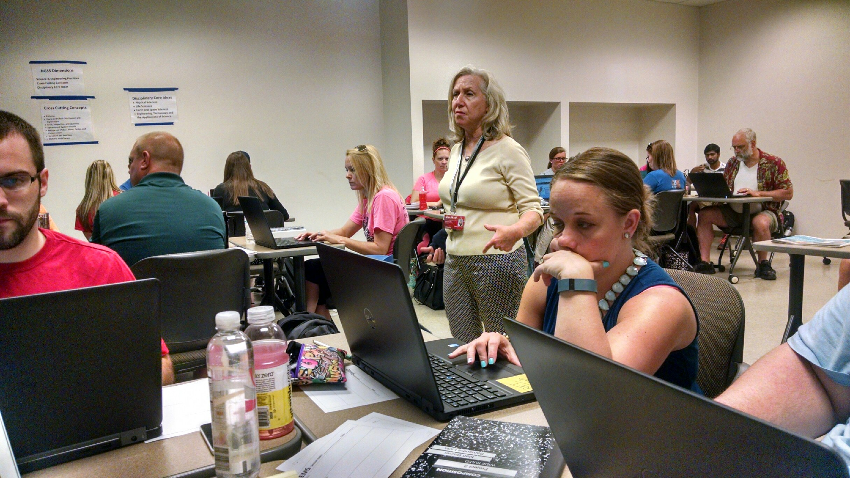
Figure 1. Ms. Debbie Liberi Discussing Units With CEEMS/RET Teachers

In order to construct a better unit, participants were asked what are the most important parts of the unit. In a large group setting, participants were asked where to start.

Some of these places to start included:
- Big Idea
- Standards
- What society needs
- A lesson that was already done

Then the discussion turned to what are some of the problem areas that the unit will have. Again, the participants were asked as a large group.

Some of the problem areas included:
- Assessments
- Hook
- Challenge
- Essential versus Guiding questions

Ms. Liberi had the next task done in small groups. Each group was to take on three tasks. The first task was to find five characteristics of a good unit, and then find five characteristics of a good activity. Each group set about this task and then presented to the large group. (Figure 2)

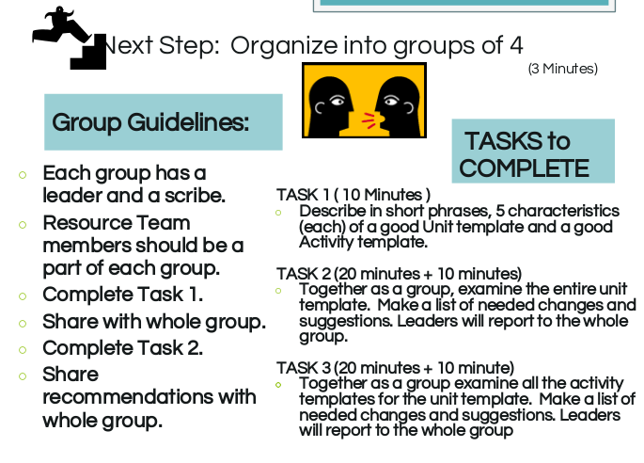
Figure 2. Powerpoint Slide Informing Participants of Directions

Examples of characteristics of a good unit included:
- Well defined challenge
- The unit covers the standards
- The unit was complete and accurate
- The assessments were aligned to the standards
- Activities were focused and had depth of knowledge
- There was a good flow to the unit
- The materials and links were contained

Another part to the first task was to analyze the activity template and find the five most important parts of a good activity.

Examples of characteristics of a good activity:
- Clearly laid out
- Scalability
- Links were available
- Prepare for challenge
- Higher level thinking
- Should be done before hand by teacher

The second task was also done in small groups and then presented to the large group. It was to look at a unit that had been finished and discuss what changes should be done to make this a better unit. The unit was based on oil spills and how they should be cleaned up.

Parts of the unit template that needed changes included:
- Too long for a unit – 18 days
- Big idea was too wordy
- Too personal in many places
- Constraints were not truly constraints
- Students were not required to present or defend their findings
- Too many activities
- Activities not clear
- No activity 5 for lesson 2

For all of the tasks the participants were divided into small groups. Each group then presented their findings. It helped with the discussion. (Figure 3)

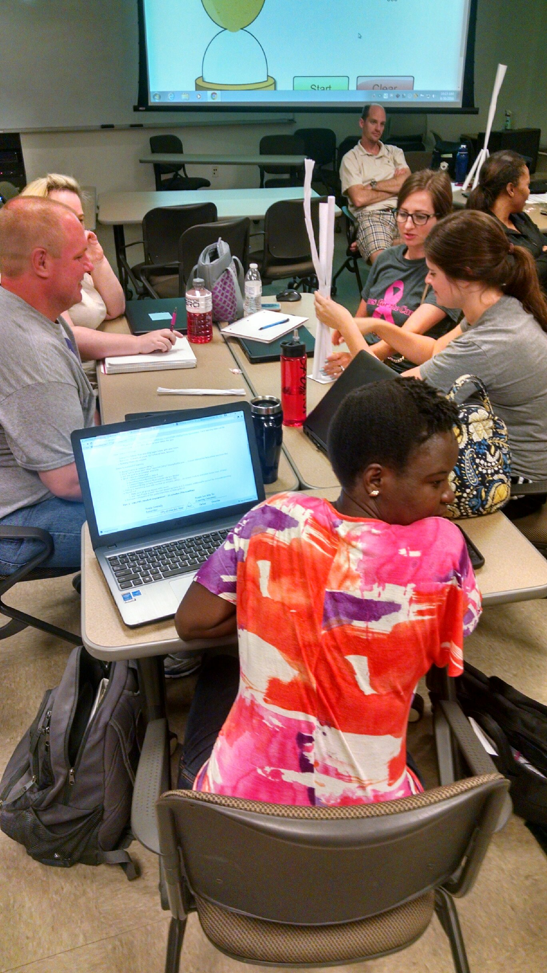
Figure 3. Participants in small group discussion

The third task was to find needed changes to the activities templates. There were seven templates and many of them had the same problems.

Parts of the activity template that needed changes included:
- Objectives were not clear
- Where did they get the content standards
- No materials listed
- Procedure for the activity was unclear
- Links and handouts mentioned but not given
- Not enough details to allow someone else to follow activity
- Too long

In conclusion, Ms Liberi asked if there were any comments about how the units are progressing for this group. Most everyone felt good or even better about their units. One final comment was made about the activities that seemed to sum up what this workshop was all about: Make sure you run your activities before you teach this unit because it helps you find what changes need to be made.

